**Full Stack Development with MERN**

**Frontend Development Report**

|  |  |
| --- | --- |
| Date | 10-07-2025 |
| Team ID | LTVIP2025TMID55695 |
| Project Name | DocSpot: Seamless Appointment Booking for Health |
| Maximum Marks | 10 Marks |

**Project Title: DocSpot : Seamless Appointment Booking for Health**

Date: 10-07-2024

Prepared by: Murari Yamini

Lingam Vennela

M Ruthwika

M Sai Tejaswi

# Objective

The objective of this report is to document the frontend development progress and key aspects of the user interface implementation for the DocSpot Seamless Appointment app.

# Technologies Used

* **Frontend Framework:** React.js,node.js,express.js, Html and CSS
* **UI Framework/Libraries:** Bootstrap and Html
* **DataBase :** MongoDB
* **API Libraries:** Axios

# Project Structure

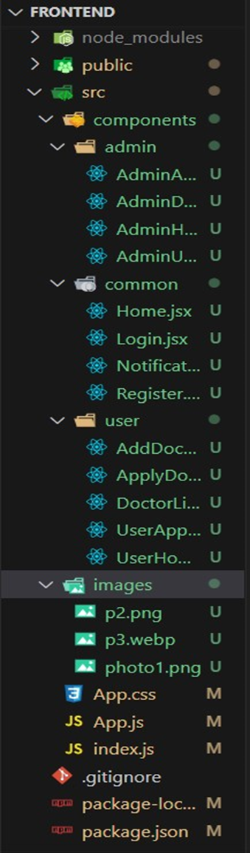

**Login Page:**

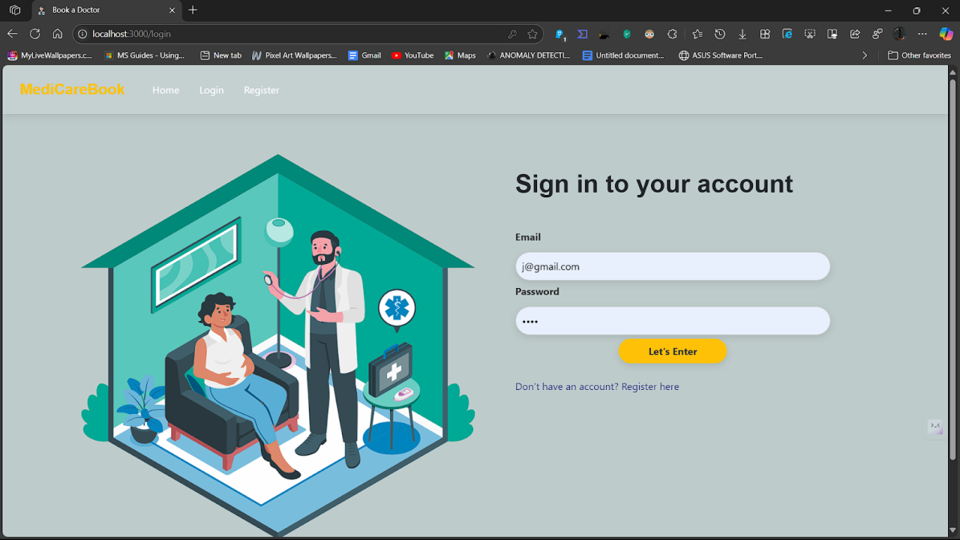

This is the Login page where users can login to their existing accounts by entering their email-id and password. This page also provides users with an option that helps new users create an account

**Register:**

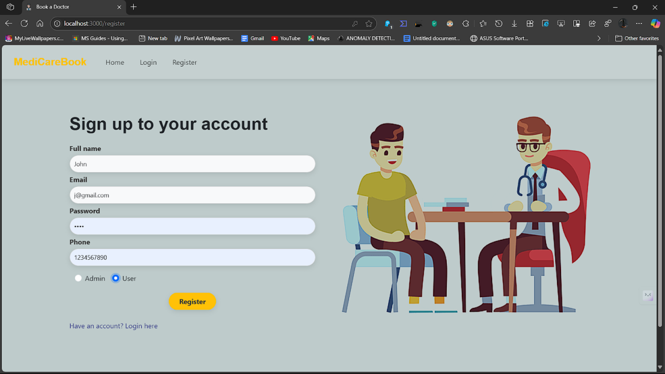

This is the Register page that allows new users create new account on entering their details like name, email, password and a phone number.

**Admin Page:**

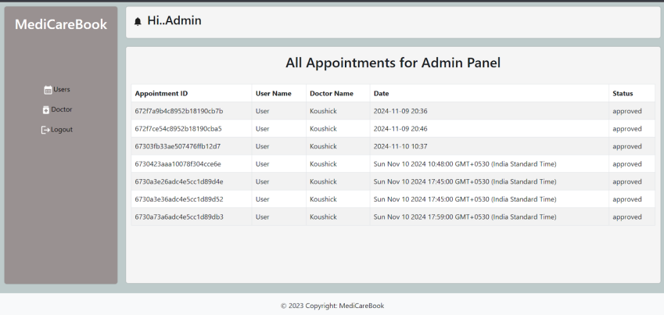

This is the main page of DocSpot, where you can easily search for Doctors . Together with user-friendly search features and tailored recommendations, you may find carefully chosen home listings here that are tailored to your preferences.

Key Components

1. **App.js**
   * **App.js** Importing various components that make up the application, such as header, footer, home page, listing page, etc.
   * Responsible for routing and main application layout.
2. **Components**
   * Each Component focuses on a specific part of the UI, allowing us to develop and test them independently.
   * Every Component typically has its own CSS file (e.g., Header.css, Footer.css) to encapsulate its styles, ensuring modular and maintainable code.
3. **Pages**

Includes different pages for Web App like

>Landing page , Register page, Login page ,Admin dashboard, Doctor and User dashboard.

# Routing

Routing is managed using React Router. Here are the main routes:

* **User -** Manage user accounts, view their booking history, and update their personal information. o **Listings -** Displays a list of all available properties that match the user's search criteria.
* **Authentication -** Authenticates user based on their username and password o **Booking –** Responsible for managing bookings

# Integration with Backend

The frontend communicates with the backend APIs hosted on [backend URL]. Key endpoints include:

o **GET /api/data** - Retrieves data for display. o **POST /api/user/login** - Handles user authentication. o **PUT/api/user/update**- Updates, adds user data in the database o **DELETE/api/user/delete**- Delete user account and clear search history

# User Interface (UI) Design

* The UI design follows

**User Personas**: Defining the target audience and their needs. Tailoring the design to meet these requirements.

**Media Queries**: Using CSS media queries to adjust layouts, font sizes, and other elements based on screen size.

**Reusable Components**: Creating a library of reusable UI components (e.g., buttons, forms, modals) to ensure consistency across the app.

**Clear Navigation**: Using a clear and simple navigation structure. Including a header with a navigation bar and a footer with additional links.

**Color and Contrast**: Using color and contrast to highlight important elements and guide users' attention. Ensure accessibility by meeting WCAG contrast standards.

* Implemented using

**Bootstrap:** Bootstrap is a popular front-end framework that provides pre-designed UI components and a responsive grid system. It's particularly useful for quickly creating a responsive and aesthetically pleasing design.

**Header and Footer:** Using Header and Footer components for margins and styling

**Third-Party Integrations:**

* axios for requesting content via HTTP.
* Dompurify, which cleans HTML inputs.
* Socket.io-client facilitates instantaneous communication.
* For displaying relative timestamps, use timeago.js.